

**MEMORANDUM OF UNDERSTANDING**

This is a document validating an agreement between **MR. OGABOR JOHN AND MRS. INDEFREKE BOLU** for the collaborative of 20% interest over a sum of **TWO HUNDRED AND FORTY THOUSAND NAIRA ONLY (N240,000) paid on the 17th of May, 2020.**

There is a binding agreement to pay the initial capital invested, alongside the interest, **TWO HUNDRED AND EIGHTY EIGHT THOUSAND NAIRA ONLY (N288,000) on the 17th of June, 2020** by **MR. OGABOR JOHN TO MRS. INDEFREKE BOLU.**

Attached with this document is an evidence of payment by **MRS. INDEFREKE BOLU.**

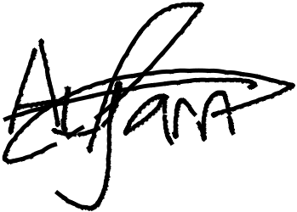

_________________________

_~~__~~_____~~___~~_~~_~~___________



**MRS. INDEFREKE BOLU**

**MR. OGABOR JOHN**

***(CEO, JOHN INVESTMENTS)***